**SCREENSHOTS**

**Screenshots of my project**

**Screenshots: - Each and every modules**

**Each and every function and sub function**

**Each and every part of the project**

**With all the features included in it.**

**With proper explanation within the screenshot’s with the highlighted technique for easy understanding.**

* MEMBERS

1. How to add new Member?

▪

Click On +Add Mem

ber

▪

Enter Details and Click On Save Button

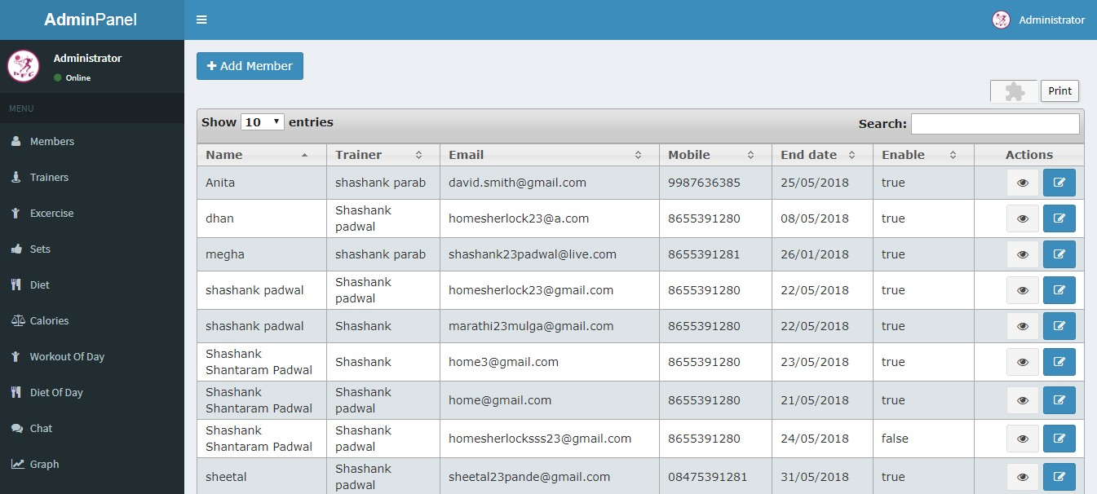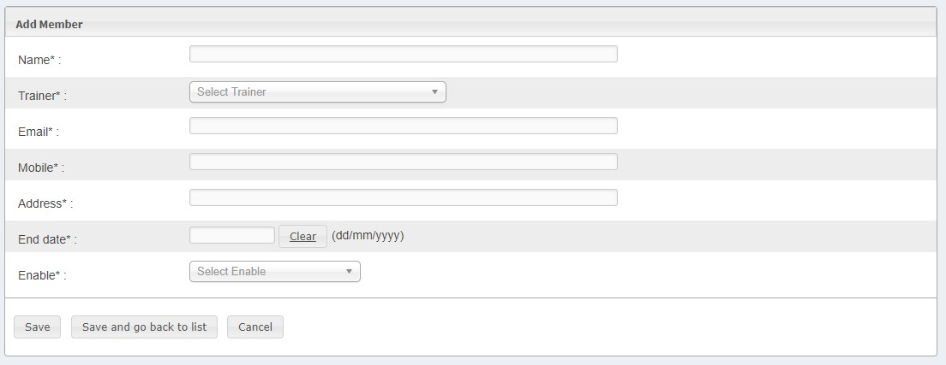

❖

For View Member details

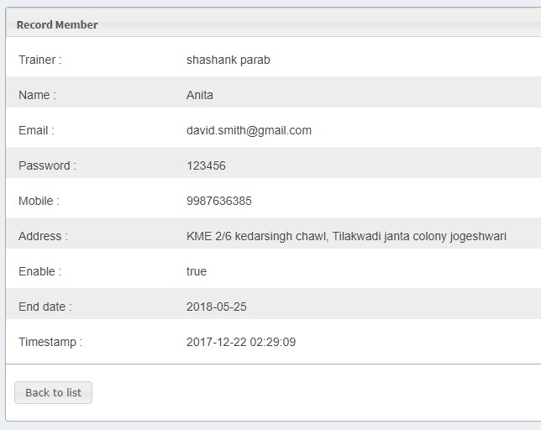

* For Edit Member Details

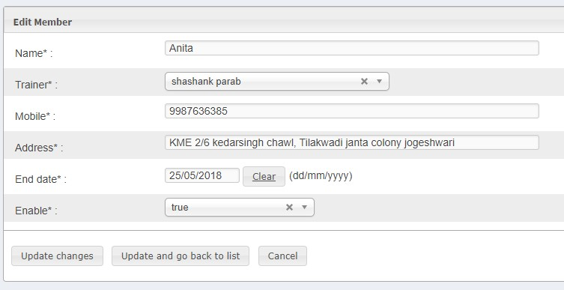

* Click on Export Button to Export records as in excel file.
* And Click print button to print the member’s records.

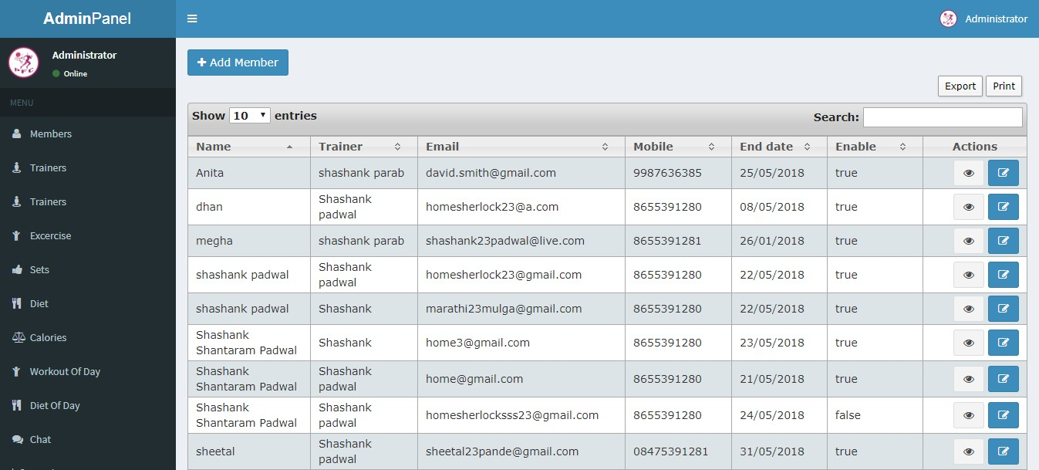

Export Members

Records As Excel File



Click here for print

the member record



2. How to add new Trainer?

* Click on Add Trainer → enter the details → submit

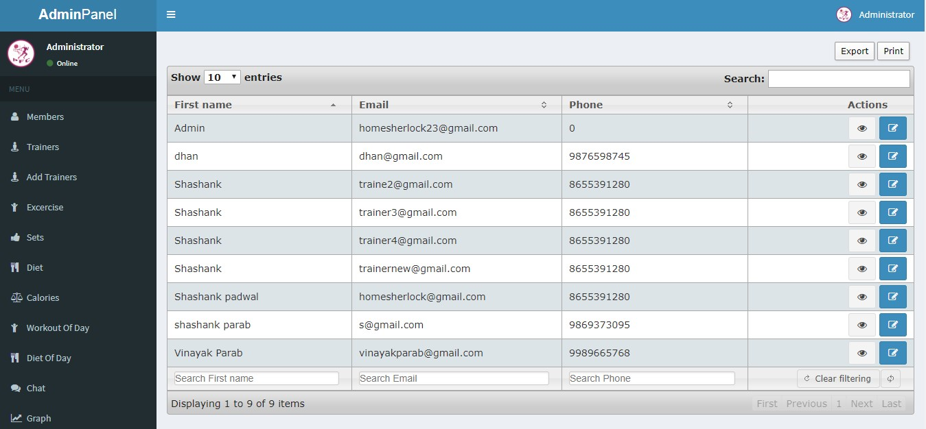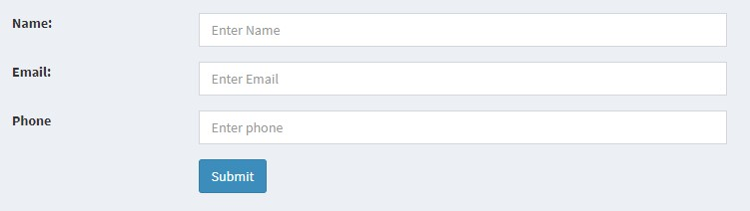

❖

For View Trainer

Details

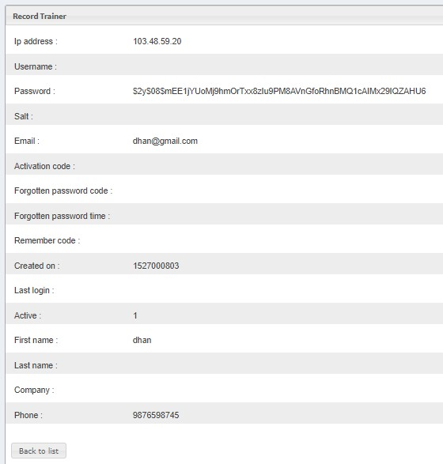

For Edit Trainer

Details

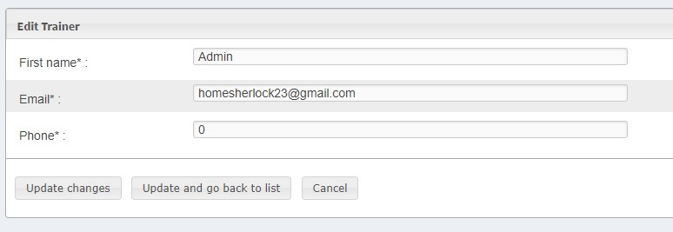



1. How to add new Exercise?
   * Click on Add Exercise → Enter Details → and Save.

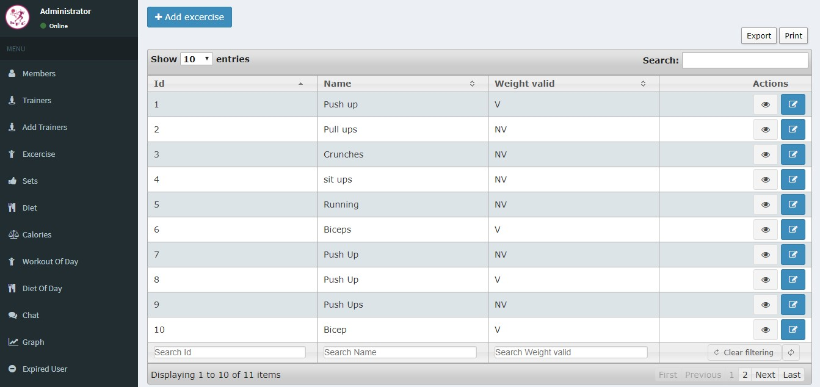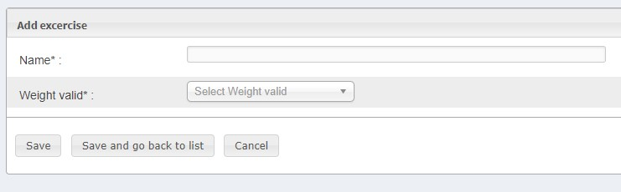

* + For View Exercise details



For Edit Exercise Details

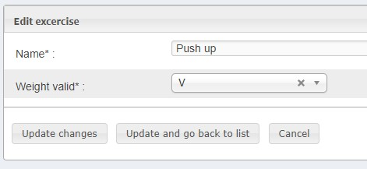



1. How to add new Sets?
   * Click on Add Sets → Enter Details → And Save.

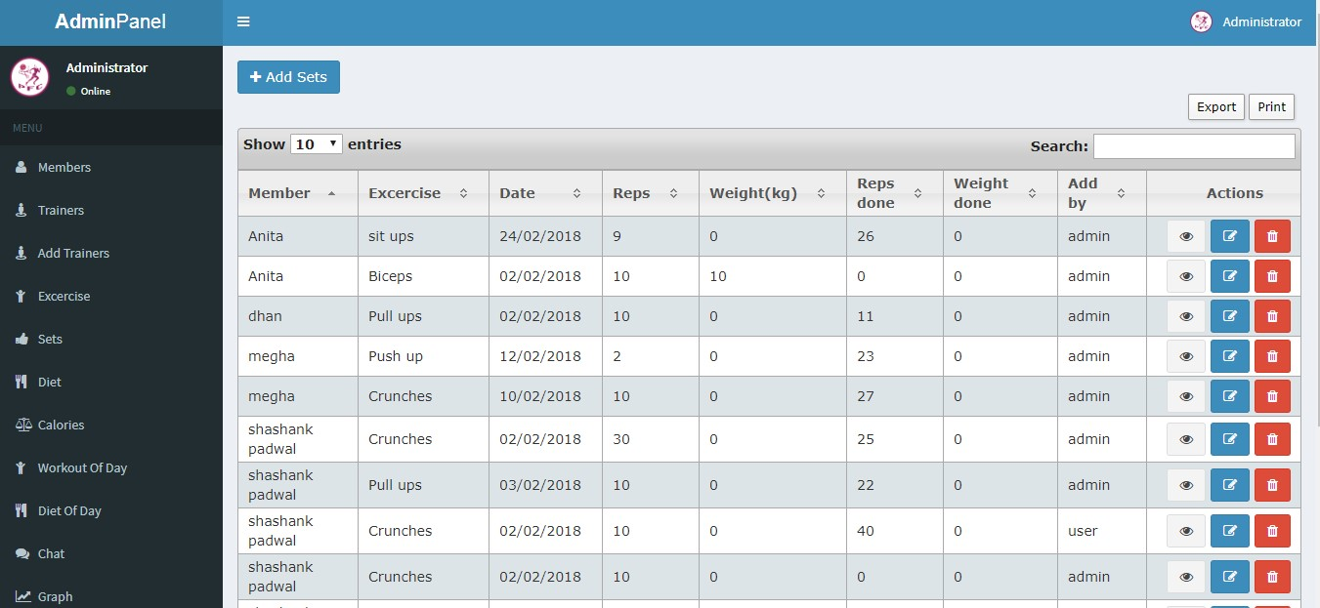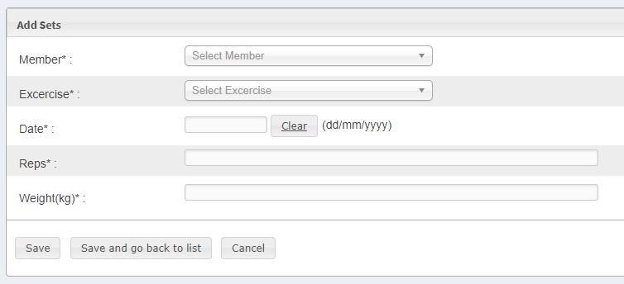

* + 1. For View the Sets Record details
  + 2. For Edit the Sets Record details
  + 3. For Delete the Sets Record details



1.

Here View

the Sets

Record details



2.

Edit Sets Record



3.

Delete Sets Record

 

4. How to add new Diet Item?

* Click on Add Item → Enter Details → and Save.

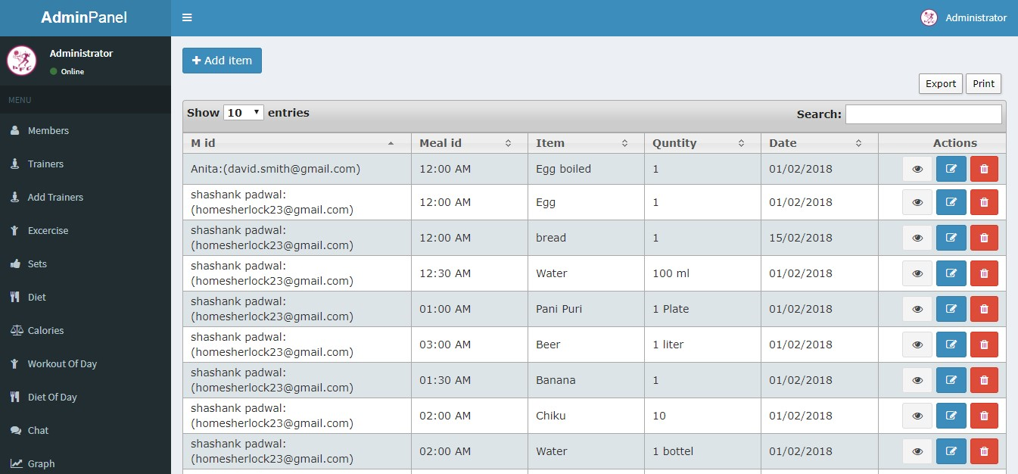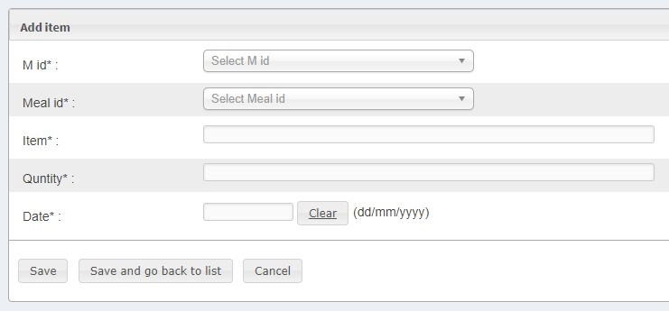

* 1. For View the Diet Item Record details
* 2. For Edit the Diet Item Record details
* 3. For Delete the Diet Item Record details



1.

Here View

the Diet

item

Record details



2.

Edit Diet Item

Record



3.

Delete Diet Item

Record



4. How to add new Food Calories?

* Click on Add Food → Enter Details → And Save

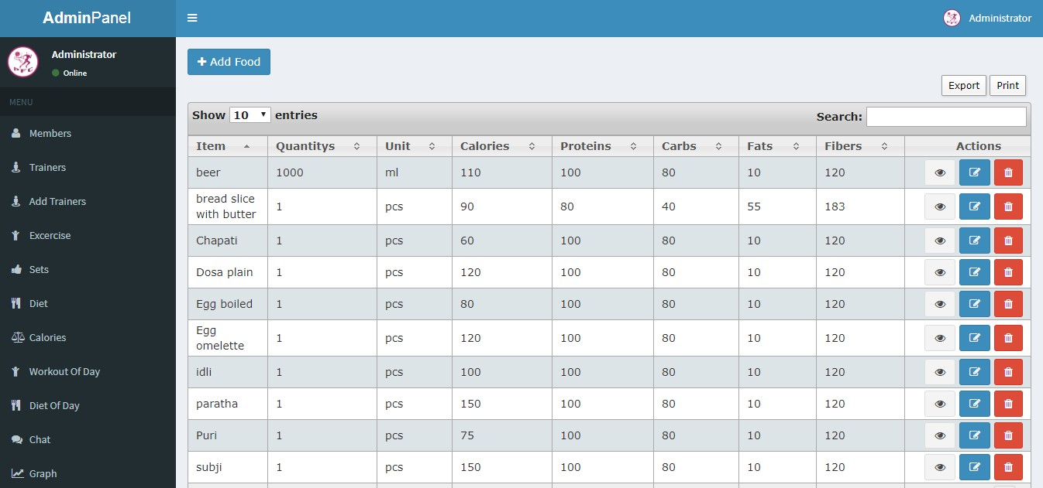

1.

Here View

the Food

Calories

Record details



2.

Edit

Food Calories

Record



3.

Delete

Food Calories

Record

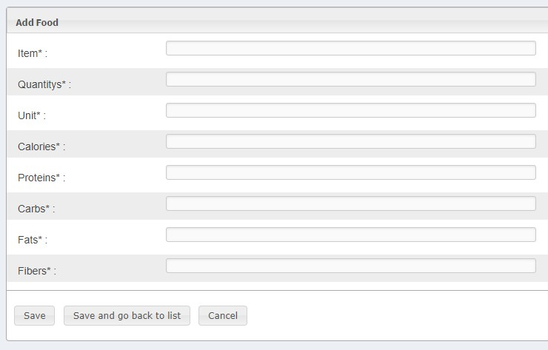

* 1. For View the Food Calories Record details
* 2. For Edit the Food Calories Record details
* 3. For Delete the Food Calories Record details



For adding new workout for particular user

* Click on select User → select date for workout → submit

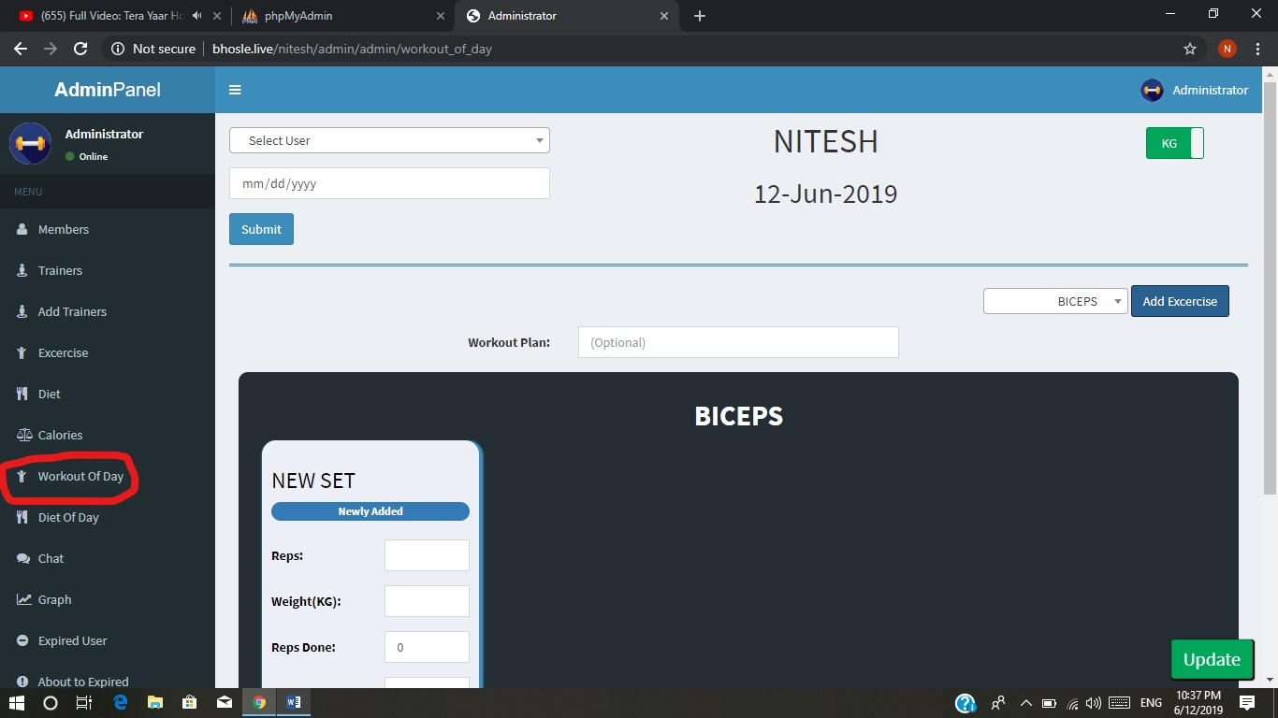

After Adding User, add exercise for that user

Select exercise → click on add exercise button

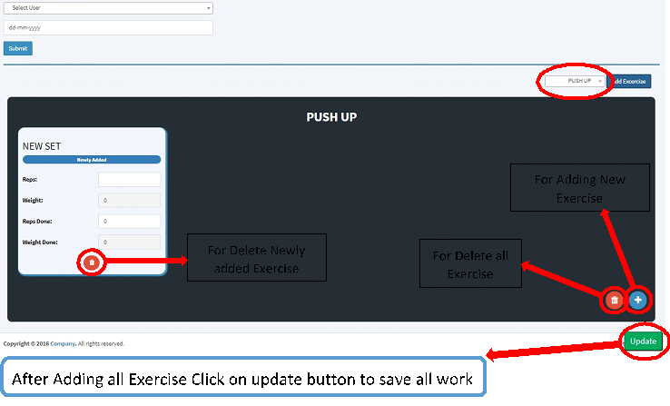



For adding new workout for particular user

* Click on select User → select date for DIET → submit

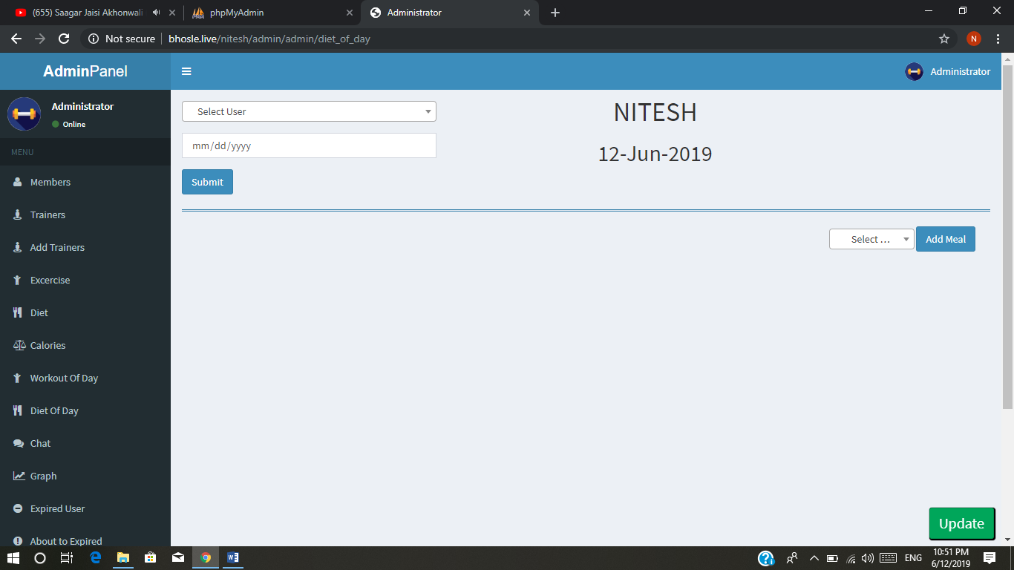

* After Adding User, add exercise for that user Select Diet Time → click on add Meal button

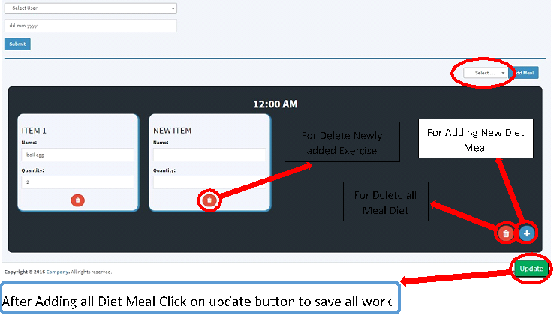

For New Chat

* Select user → type message → click on submit

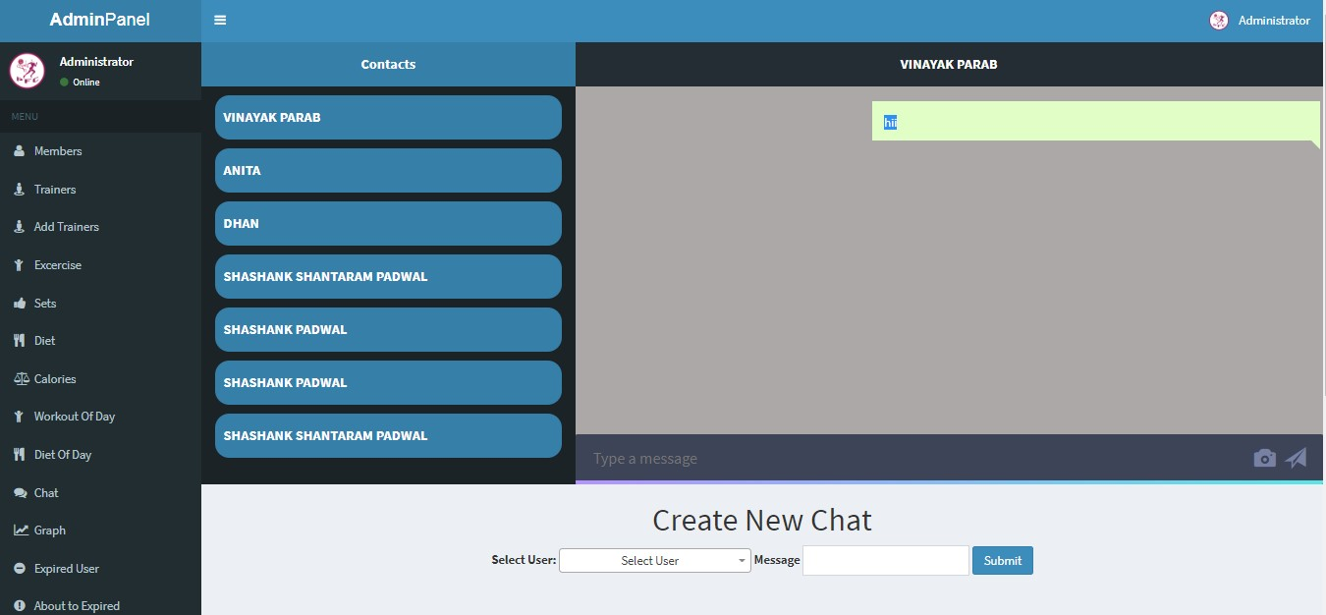

Shows Recent

Chats with User



For View Graph of user exercise

Select date → select user name → and click on submit

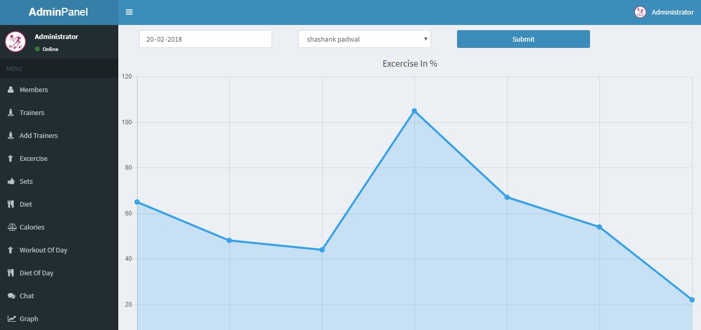



* Here Admin can see the subscription expired user list

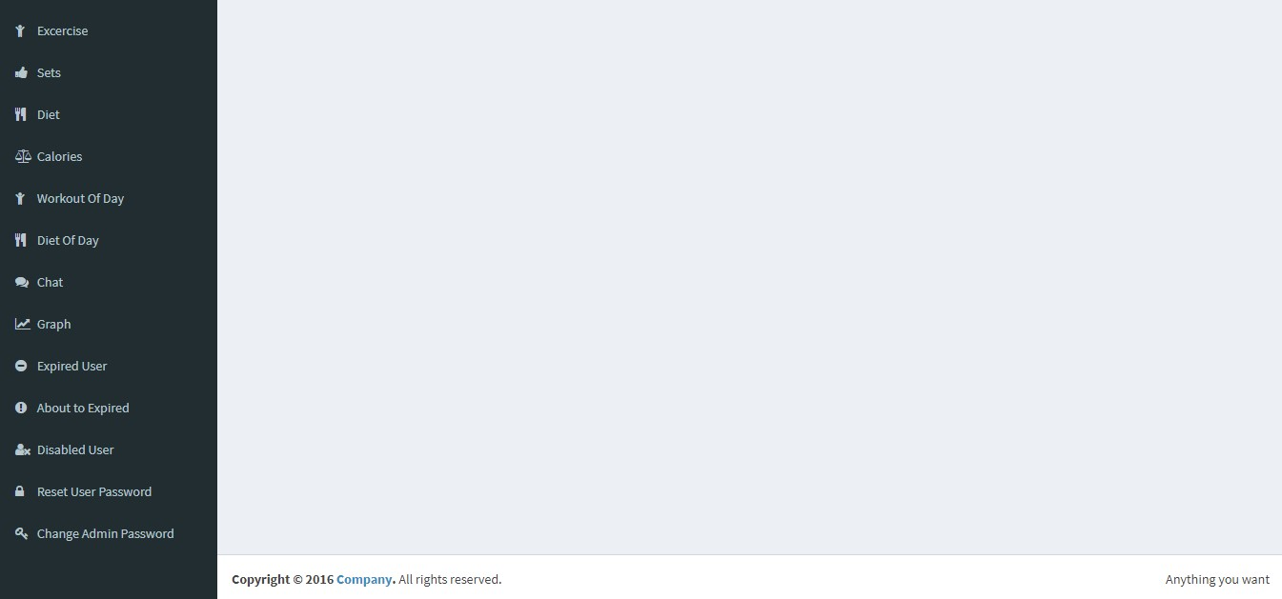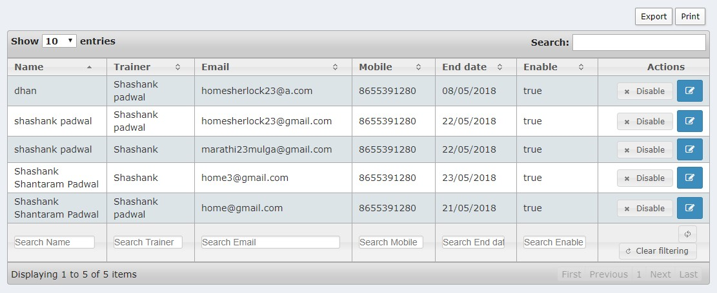

Here Admin can

Disable

the expired user



2.

Edi

t Expired user

Record

❖



Here Admin can see whose

Subscription about to end

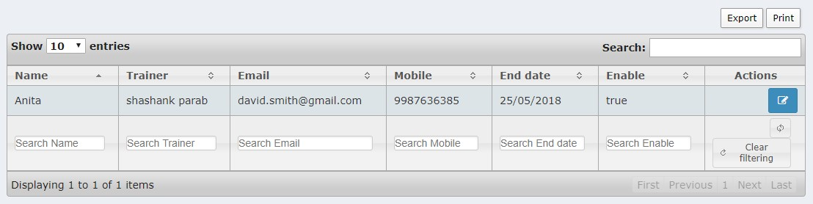

2.

Edit about to expired user

Record



* Here admin can see disabled user record

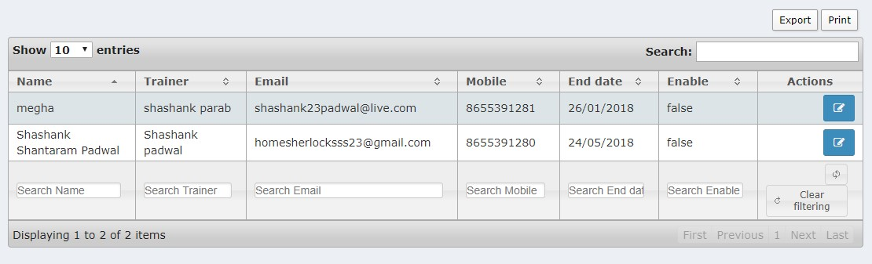

2.

Edit about to disabled

user

Record

* Here admin can reset particular user password.

Select user → and reset

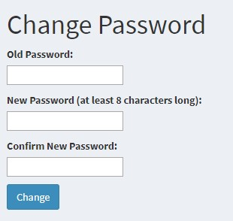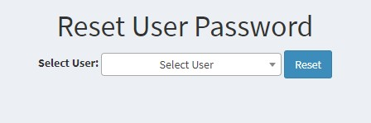

❖ 

* Here Admin Can change their account password.

For admin sign out

C

lick

Administrator

→

And click sign out..

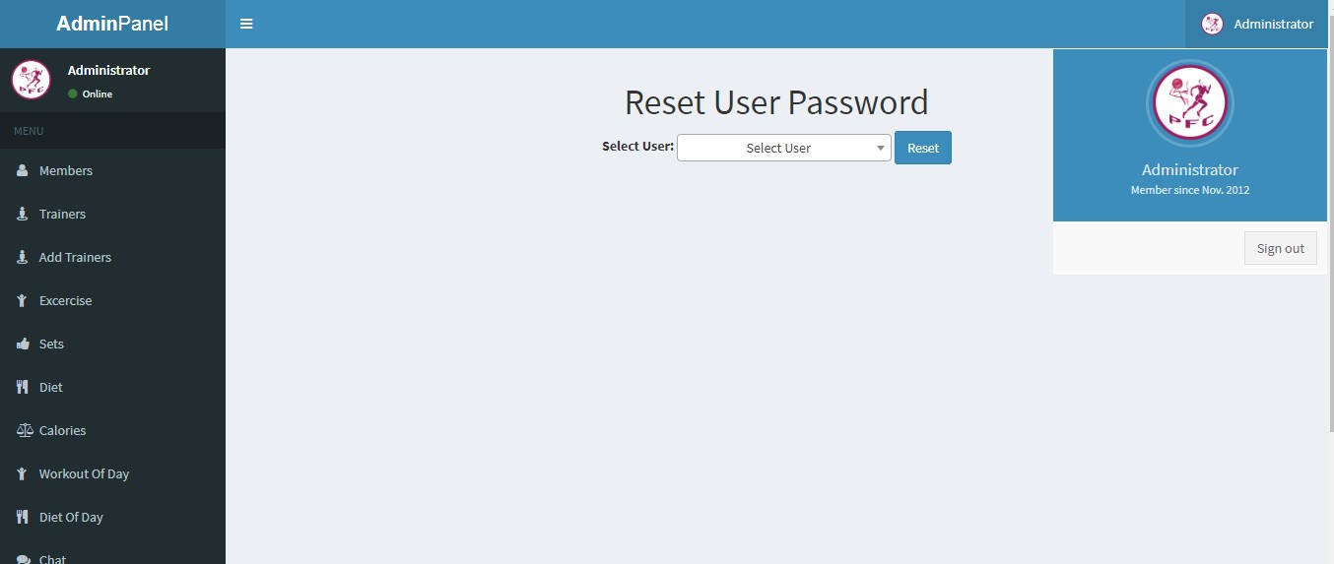

**APPLICATION SCREENSHOTS:-**

**PROGRESS:-**

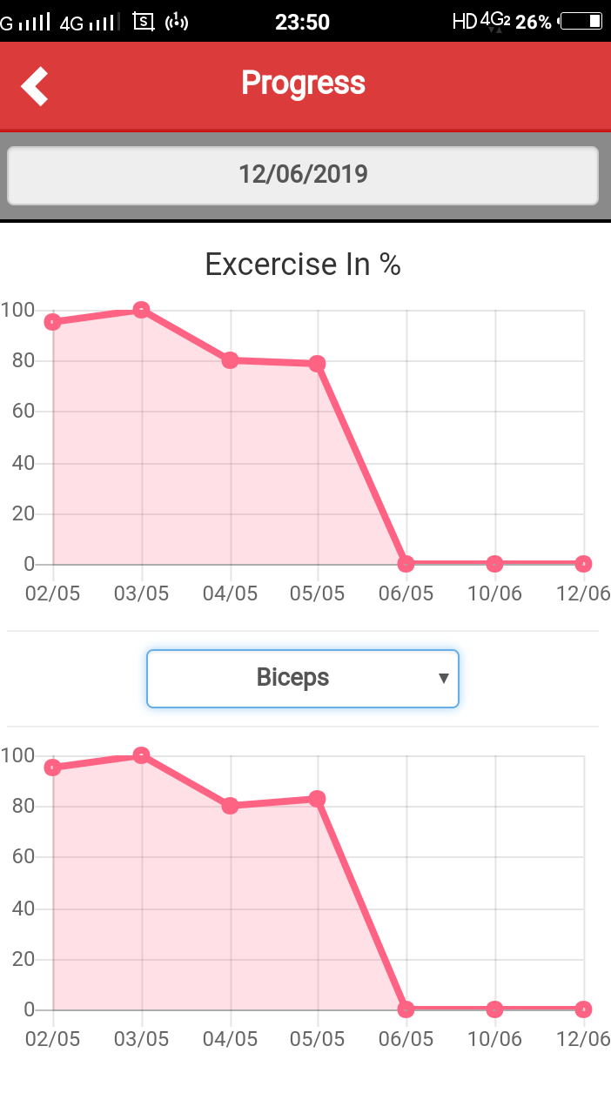

**DIET:-**

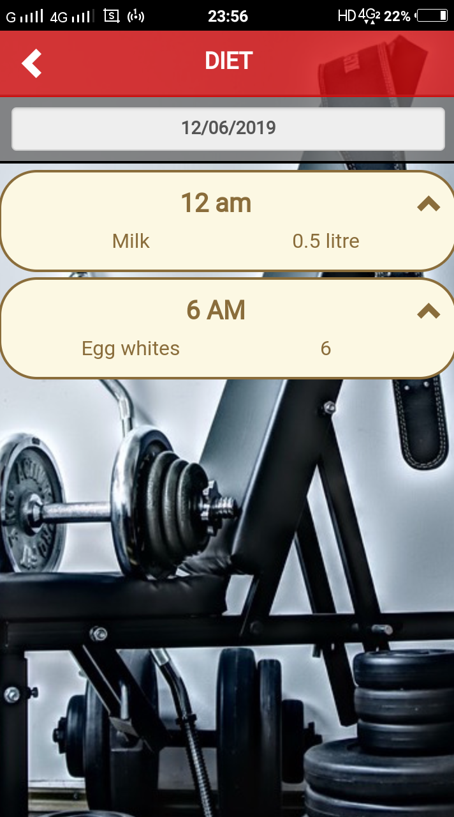

**APLLICATION TAB:-**

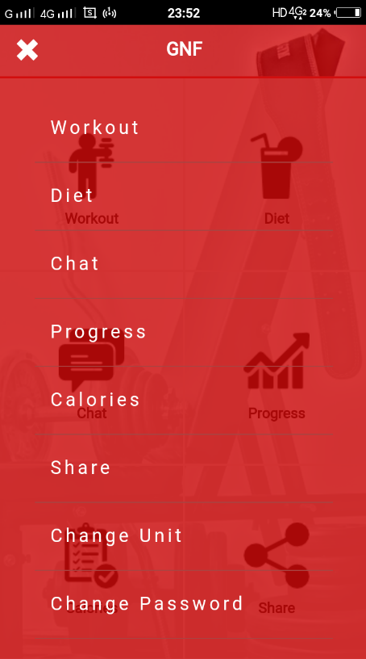

**CHAT:-**

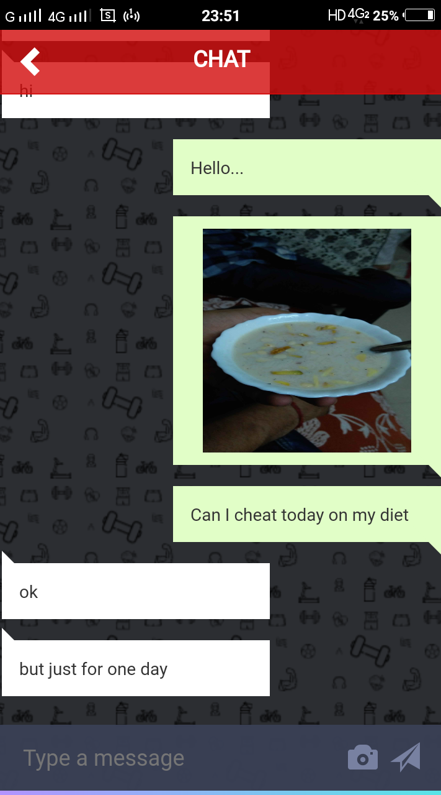

**CALORIES:-**

